**Department of Electronics and Communication Central University of Rajasthan, Ajmer**



Signal and System Lab

Subject ...................................................................................................

ECE 214

Subject Code ...................................................................................................

4

111

Experiment No. .......................................................................................

Date:- - -2024

Roll no:- 2022BTECE012

Name:- Ojasvee Satija

**Title: -** To Plot Sine and Cosine Wave in one plot using MATLAB

**Apparatus required:** - Downloaded MATLAB or OCTAVE software in device.

**Introduction:**- According to this code we are able to plot more than one plot in one graph

**Code:-**

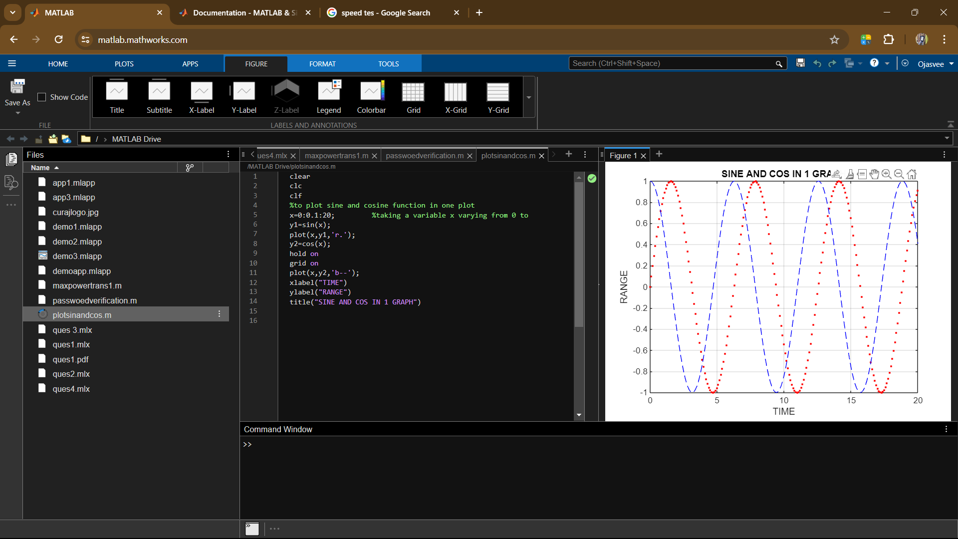

**Result:-** Plotted the sine and cosine curve on same graph.

